|  |
| --- |
|  |
|  |
| Game Design Document |
|  |
| **Kyle McLenahan, Kent Duncan, Jeffrey Lam, Stephen Zylka** |
| **1/23/2012** |

|  |
| --- |
| **Team C** |

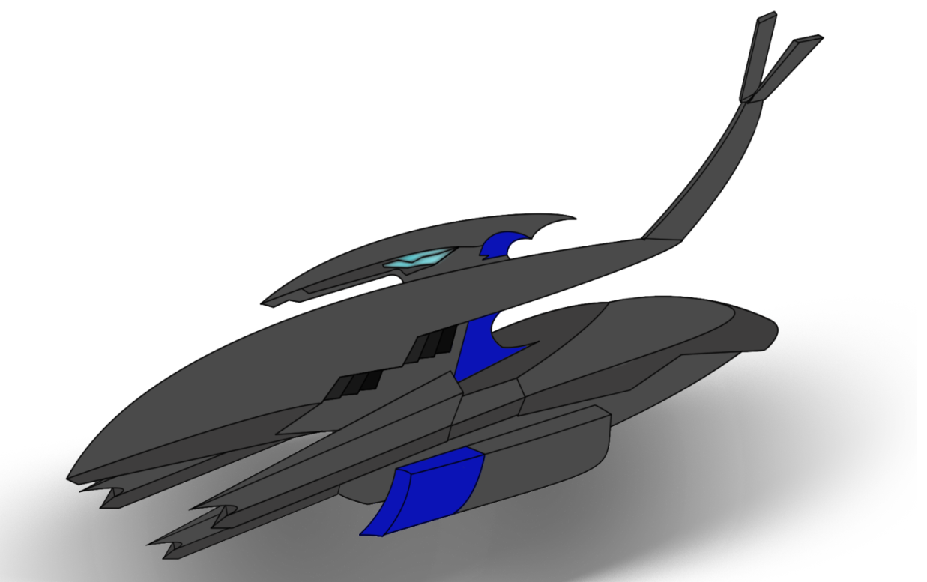

Table of Contents

1 Game Design 2

**1.1** **Game Analysis** 2

**1.2** **Game Concept** 2

**1.3** **Game Goals** 2

**1.4** **Game Genre** 3

**1.5** **Target Market** 3

**1.6** **Gameplay Direction** 3

**2** **Features** 4

**2.1** **Required Features** 4

**2.2** **Bonus Features** 4

**3** **Gameplay Details** 5

**3.1** **Rules** 5

**3.2** **Power-ups** 5

**3.2.1** **Speed Boost** 6

**3.2.2** **Projectile** 6

**3.3** **Interface** 6

**3.3.1** **Startup Screen** 6

**3.3.2** **Driving UI** 7

**3.4** **Track Design** 8

**3.5** **Exciting Moments** 8

**4** **Concept Art** 9

# 1 Game Design

Varios puts you behind the wheel of a futuristic racer in a contest that tests your reactions while besting highly competitive AI racers to be the fastest on the track.

Fast paced racing and moments of pure speed define Varios as you work to overtake your opponents at breathtaking rates.

Power-ups are powerful tools that boost your own performance, allowing you to take game changing shortcuts that will throw your opponents for a loop.

Mastering the use of projectile power-ups is essential in overtaking your fellow racers, and sending your enemies to the back of the pack.

Each race will be different than the next, as highly intelligent AI racers will aim to pass you any chance they get while you contend with the numerous challenges the track poses.

* 1. **Game Analysis**

Varios is a casual, futuristic racing game similar to games like Mario Kart and Diddy Kong Racing.

* 1. **Game Concept**

Varios is a futuristic racing game that pits the player against multiple AI driven racers in a bout that requires skillful driving at high speeds, and accurate firing of projectiles to best your opponents.

Each race declares a single winner based on the racer with the fastest time accumulated after the player completes the required number of laps.

* 1. **Game Goals**
* The main goal of Varios is to provide a FUN racing experience for the player, not a realistic one.
* The player’s vehicle should be easy to control and get the hang of, creating an easy to jump into game experience.
* A power-up system that allows players and AI racers to increase their performance by boosting things such as speed, as well as disrupt other players.
* Three power-ups can be held at a time, allowing racers to hold onto power-ups until they are needed most.
* AI controlled vehicles, combined with a performance boosting power-up system should provide a dynamic experience each time the player races.
* Certain power-ups should allow all racers to take shortcuts that will significantly reduce their lap time if used properly. This is intended to create a heart pounding sense of urgency, as any other racer could close in on the player in the blink of an eye.
  1. **Game Genre**

Varios is a casual futuristic racing game built for the PC, intended for gamers who wish to enjoy a simple, yet fun and exciting racing experience. Use of an Xbox 360 USB controller will be required to play.

* 1. **Target Market**

Our target market for Varios is anyone who wishes to enjoy a casual racing experience. This entails all age groups, and any gamer who is not looking for a hardcore, realistic racer.

Varios should be simple enough to appeal to anyone, yet pose enough challenge that seasoned players and newcomers alike will want to continue playing in order to master their racing abilities.

* 1. **Gameplay Direction**

We want players of Varios to have an enjoyable, casual racing experience that they can jump right into. Our main goal is to focus on solid driving mechanics, and a fun world to drive in; solid track design with a number of shortcuts is essential in creating this atmosphere.

While players should find the controls simple and intuitive, level design should pose the player with enough challenge that they wish to race again and again trying to master the level. As well, every time the player races, we expect them to have a different experience due to the attacking AI racers as well as the power-up system that allows for disruption of other racers. This system will not allow players to simply master the track and then drive the same each time, but will instead force a more reactionary style of gameplay.

Gameplay will be centered around both speed and chaos, as all racers will be consuming numerous power-ups. Being in first place at any given time will not be a good indicator that the player will win the race, but will instead instill fear in them since every other racer is gunning for them. Conversely, when the player is in last, all hope is not lost, as a single shortcut could launch them ahead of the pack.

1. **Features**

Fun is the name of the game and these features will be the central focus to delivering it.

* 1. **Required Features**

**Power-ups:** Boost your own speed or nail your enemies to propel yourself to first place.

**Shortcuts:** Hang onto your power-ups and use them strategically to take a quicker route to the finish line.

**Intelligent AI:** Other computer-controlled racers will be constantly vying to overtake you through any means necessary.

**Challenging Track:** This isn’t NASCAR, and our track reflects that with sharp turns, jumps, obstacles, and terrain that will keep you on edge.

* 1. **Bonus Features**

These features may be implemented if we find them to be fun and we have enough time to do so, but Varios will not be planned around them.

**Additional Power-ups:** Improve your traction on uneven surfaces or bash your opponents off the track with endless power-up ideas.

**Dynamic Track:** Driving over buttons on the track can add or remove objects such as ramps or walls, allowing you to take an easier path, or block that path for others.

**Multiple Vehicles:** An assortment of vehicles at the player’s disposal can be selected, all with varying statistics, to give the player a fine tuned automobile that suits their personal play style.

**Additional Tracks:** Multiple tracks with varying degrees of difficulty will keep players entertained for hours, and provide a high level of variety for player’s to enjoy.

**Multiplayer:** Bringing more players to the table is always a good thing, and will be sure to add another degree of challenge and uncertainty. This may be done by allowing multiple people to play on the one computer.

1. **Gameplay Details**
   1. **Rules**

Each race will consist of one human player and a number of AI controlled racers on a track. Once the player completes the required number of laps to finish a race, the race will end. AI racers who are currently behind the player will be allotted a projected time based on their current position on the track. Every racer will then be ranked according to the speed at which they completed the race, with the racer who obtained the lowest time coming in first place. How any racer gets the fastest time however is completely up to them.

* 1. **Power-ups**

Every racer on the track will be able to accumulate up to three power-ups by driving over them. After each power-up is picked up, they will then surround the racer. At any point during the race, if a vehicle has at least one power-up they may choose to use it and gain the benefits it offers. Once a power-up is used, it will disappear and the racer will be forced to pick up more.

* + 1. **Speed Boost**

By using a speed boost power-up, the vehicle will gain a temporary boost to their current speed. This can be used to pass your opponents, or jump large gaps that a vehicle could not normally pass over without increased speed.

* + 1. **Projectile**

When a racer uses a projectile power-up, it is fired in the direction the racer is currently facing. If another racer is fairly close to the fired projectile, the projectile will then seek out that racer until it strikes it. Upon striking another racer with a projectile, the target that was struck will be temporarily disrupted.

* 1. **Interface**

The interface we have designed is simple enough that new users can start up a game and understand everything they see on the screen very quickly, as everything is represented in a familiar manner to other racing games.

* + 1. **Startup Screen**

The startup screen will have only three options: New Game, Options, and Quit. The “New Game” option will drop the player right into the game, while the “Quit” option will ask the player if they wish to exit before exiting entirely. Within “Options”, the player should be able to view the controls for the game, change the difficulty of AI racers, and play with the volume of the sound.

* + 1. 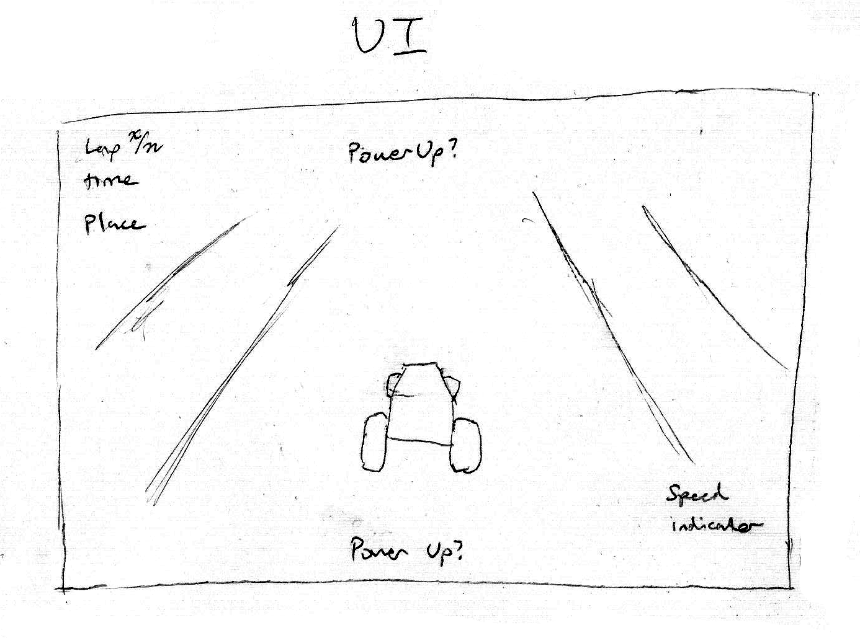**Driving UI**

The UI while driving will not be intrusive and will only serve to give the player an indication of their current status. Any lap related information will be placed in the top left corner of the screen. This includes the player’s current lap, lap time, and place in the race. Power-ups may be displayed on the top or bottom of the screen, or they may be surrounding the vehicle – negating the need to display them anywhere else on the screen. In the bottom right of the screen will be a speed indicator, which will display the player’s current speed in a stylish manner.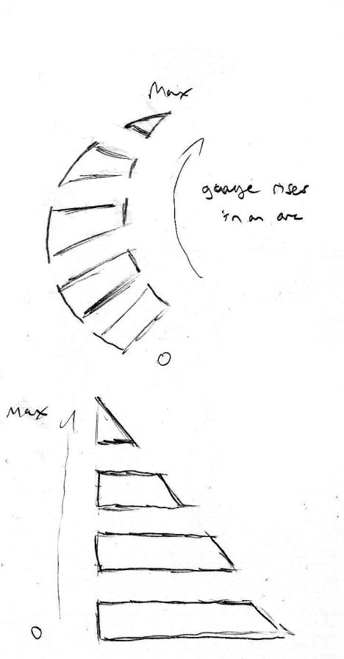

**Speed Meter Concepts**

* 1. **Track Design**

The track is designed to pose enough challenge of its own to the player that they would have trouble getting the best time possible, even if there were no AI racers. The addition of AI racers obviously makes things more hectic and difficult, so we will add multiple shortcuts that can be taken by any racer, which will propel them forward many places. Some shortcuts may be smaller than others, but will not require a power-up to properly use. Other shortcuts will give racers a large advantage, but only if they have a power-up they can use to take advantage of the shortcut. Trying to access a shortcut without the required power-up will surely result in disaster.

* 1. **Exciting Moments**

While Varios is sure to be littered with exciting moments, there are a couple key moments we hope to manufacture for the player. The first of these is a racer taking a lead changing shortcut. As cars are flying down 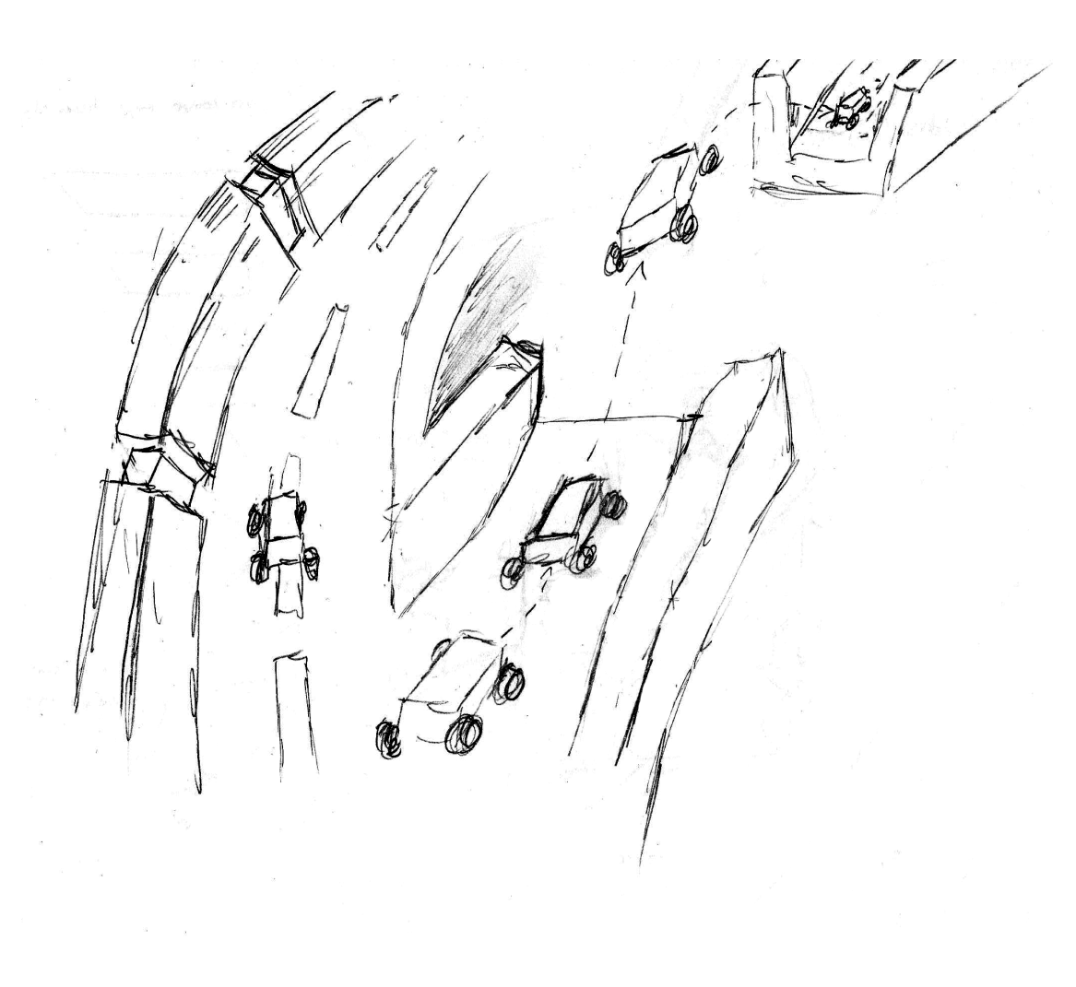the track neck and neck, one racer is able to snatch a speed boost power-up. The racer times it just right and uses it to launch them off a ramp and clear a large gap that they could otherwise not make it over. Every other racer without a speed boost power-up is then left to take the long way around the jump, being left in the dust.

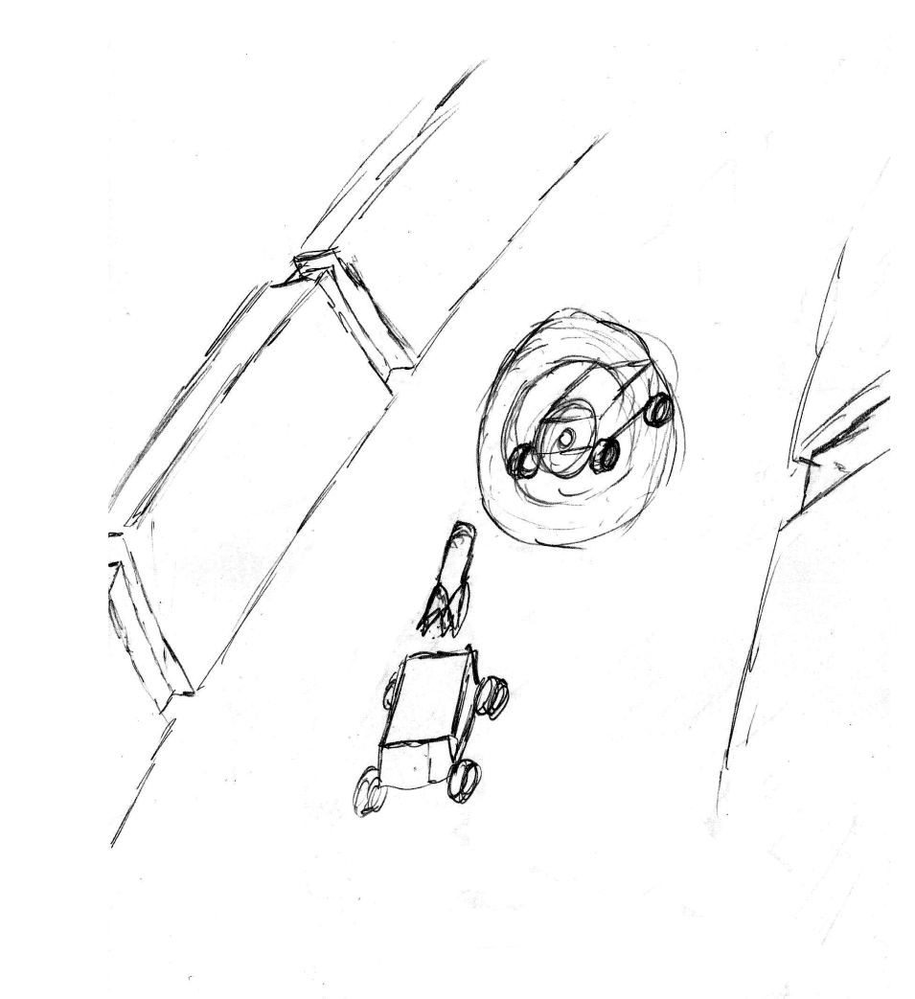

The other key moment that we aim to have often is the strategic use of projectile power-ups. While many projectiles are sure to be fired throughout the course of a race, it’s the perfect hit at just the right time that gives the most satisfying feeling. It could be as another racer is trying to take a shortcut, you want revenge, or you need to pass your opponent right at the finish line; if you land that shot, nothing feels better.

1. **Concept Art**

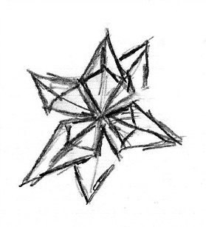

**Power-up on the track**

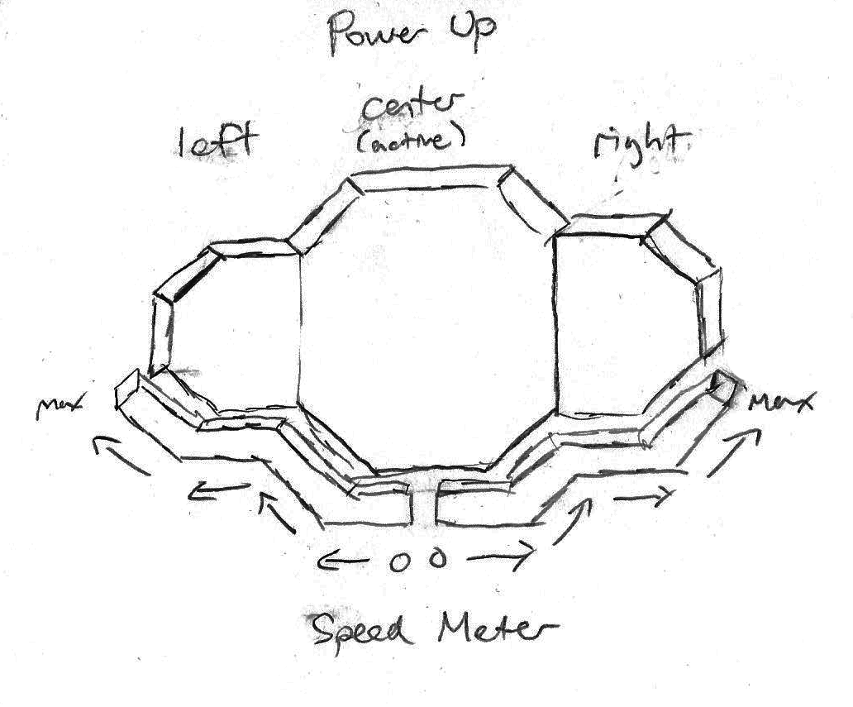

**Power-up display w/ speed meter**

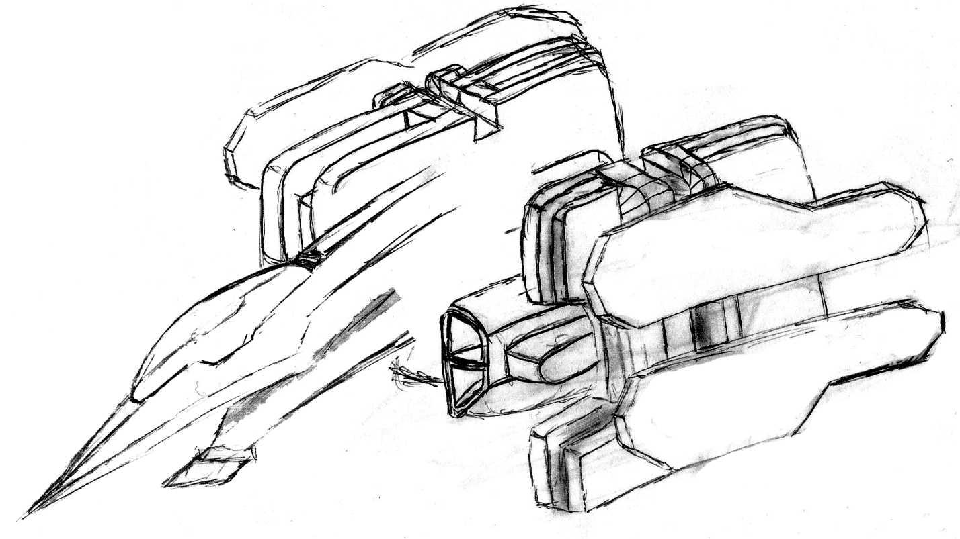

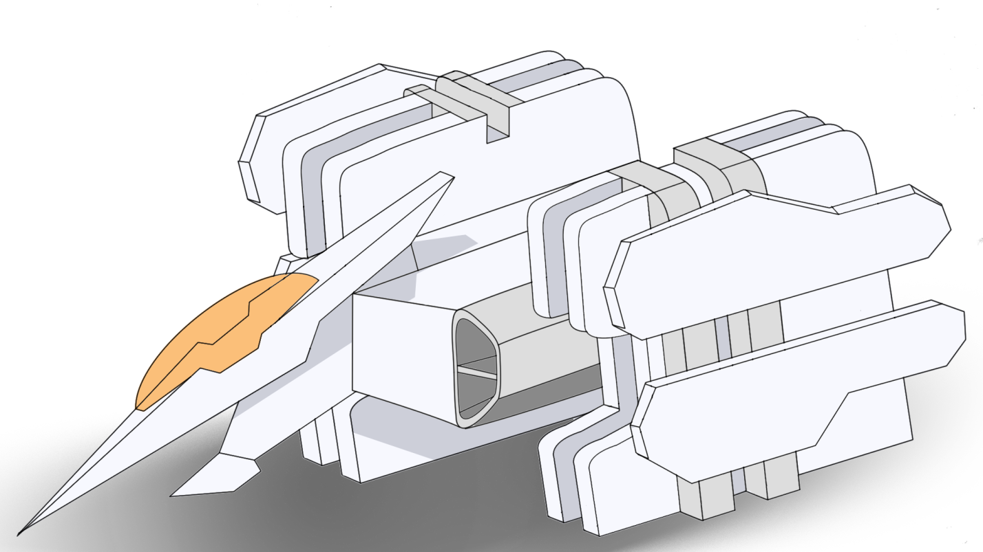

**Another idea for vehicles**

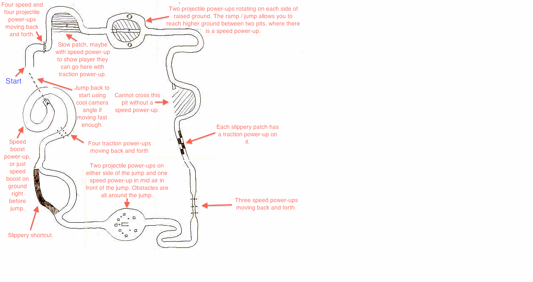

**Track Design**